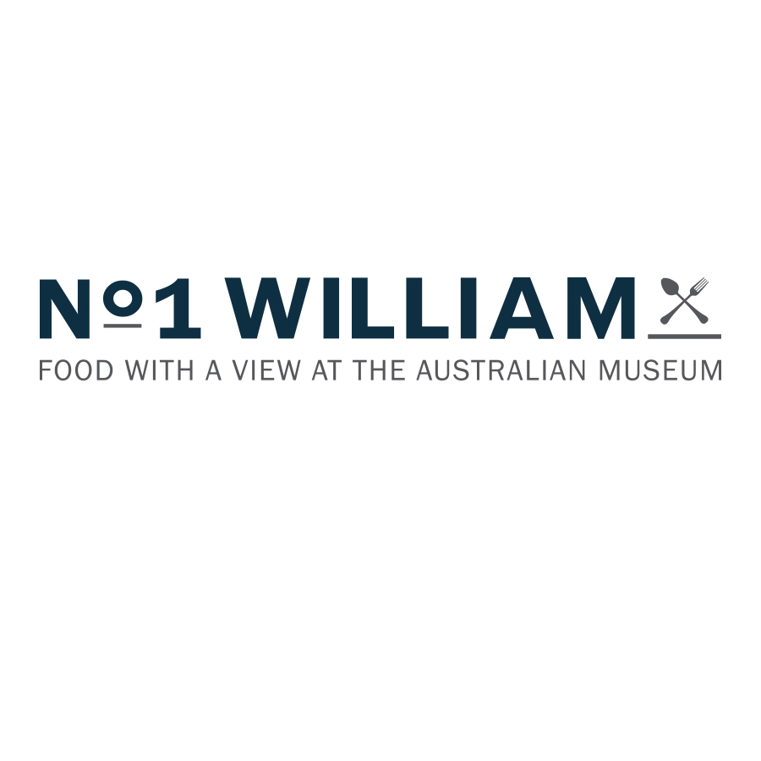

$45 for 2 courses or $55 for 3 courses*
Including a regular tea or coffee

Entrée
Archie rose gin cured ocean trout and almond curd tart, fragrant raw salad, flowers df
Shredded duck and watermelon salad, cashews, rocket, chilli, coriander, light hoisin dressing df
Smoky carrot and bitter leaf salad, roast beetroot passata, macadamia salsa gf, vg

Main
Dry rubbed 220g Sirloin steak, grilled cabbage, zucchini flower chimichurri gf, df
Market fish with shaved fennel and cucumber salad, peppers, saltbush aioli gf, df
Spiced eggplant, whipped garlic, cherry tomato, red sorghum and mint tabbouleh vg, gf

Dessert
Lemon aspen curd tart burnt wattleseed meringue
Coconut sorbet, macadamia praline, mango, Davidson plum dust v, gf
Sweet-spiced cake, raspberry sorbet, butterscotch popcorn gf

Sides
Freshly baked baguette, Victorian EVOO v $6.50
Native ancient grains, Persian feta, herbs v $8
Mixed leaf salad, vinaigrette v, gf, df $8
Fries, chicken salt, tangy aioli $8
Parmesan roasted zucchini gf, v $9

*to be taken by the whole table

